**Laboratory Exercise #6**

**Encapsulation**

Name/s: Princess Pearl C. Dela Rosa

Yhasnaya Franchette T. Soriano

Section: BSCPE 1-5

Date: June 17, 2024

Instructions:

Design a bank system which represents bank accounts and its operations, transactions and interactions between bank customers, bank tellers, and bank manager as described in the UML diagram below. Use inheritance to organize your classes and use encapsulation to manage data access of each class.

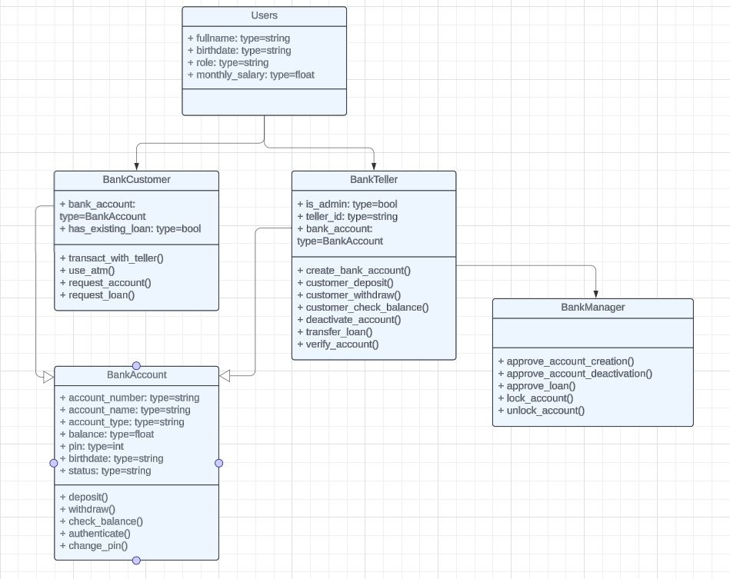

The bank system works as follows:

1. There are three types of users: bank customer, bank teller, and bank manager.
2. Bank account has two types: savings and payroll. Savings are for bank customer while payroll are for bank tellers and bank manager. Payroll accounts can only use the ATM for its transactions.
3. Initially, bank customers have no bank account yet so they can request an account to the bank teller. Once they have an existing bank account, they can no longer request for another one.
4. Bank customers can only have 1 bank account. They can access it via two options: 1) transact with a teller and 2) use ATM machine.
5. If bank customers opt to transact with the teller, they can deposit, withdraw, and check balance but they can’t authenticate and change their pin.
6. If bank customers opt to use the ATM, they can deposit, withdraw, check balance, authenticate, and change their pin. Though the deposit and withdraw have a limit amounting to 20,000.00. If they want to deposit/withdraw higher than the limits, they can transact with a teller.
7. Bank tellers can create or deactivate bank accounts, but they need approval from the bank manager.
8. Bank tellers can deposit, withdraw, and check balance on behalf of bank customers, only if the bank customer provided the account number. For withdrawal and check balance transactions, bank tellers must verify the account number with the customer (e.g. check if birthdate is matched)
9. The bank manager is the admin, he/she can do all the things a bank teller can do and there’s no need for approval.
10. A bank customer can request a loan. The bank manager approves loan if it is amounting to less than or equal to 400% of the monthly_salary of the bank customer (example: if the monthly salary of a bank customer is 50,000 then he/she can request loan up to 200,000.00). Also, the loan is approved by the bank manager only if the bank customer has no existing loan yet from the bank.
11. Once loan request has been approved by the bank manager, a bank teller can transfer the loan to the customer bank account.
12. The bank manager can lock or unlock bank accounts, when a bank account is locked, all transactions cannot proceed.